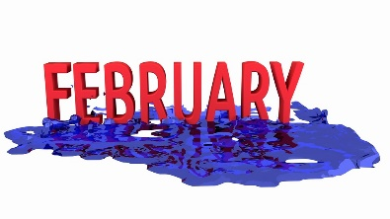
Bookbeat Froid Public Library

Pageturners Book Club: We will be discussing Before We Were Yours by Lisa Wingate on Wednesday, January 25th at 11:00. Our next book will be Still Life by Louise Penny.

Thank You!
The library has received a generous check for $1550 from the community fund drive. The town’s support of our library is very much appreciated.

Nyquist Foundation: I have received word that The Nyquist Foundation has approved a grant of $1000 to continue expanding The Thomas and Corinne Nyquist Montana Collection in our library over the next four years. This collection is one of the best in this part of Montana. Come in and check it out, literally!

AWE Early Literacy Station: This computer specifically for kids is on the East wall of the library. It is a standalone computer that is not connected to the internet. It has over 70 preloaded programs covering reading, math, science, social studies, writing, art, music as well as a reference section. It has a colorful touchscreen that children can easily navigate.

Froid Library Hours: 11 to 5:00 Tuesday, Wednesday and Thursday

