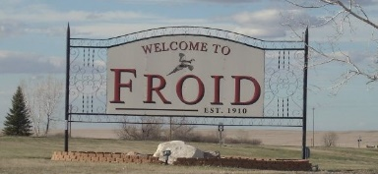

May 2, 2019
Hello friends!
Can you believe it’s been over 10 years since our last letter? We hope this letter finds you in good health and good spirits!
The Town of Froid and the Northern Lights Park are kicking off a new fundraising campaign to complete various maintenance and improvements in our town of Froid.
Since the last fundraiser which built our beautiful Froid Community Center, Firehall and Library many improvements and updates have been made and, such is life, we have experienced a few notable setbacks. Our corner of the world has seen many years of good moisture and good crops for which we’ve been truly thankful. More recently, the past 3 years has brought us record breaking drought, devastating hail storms, and the lowest crop prices in the last decade. Despite these challenges the spirit of our Froid citizens has not been broken.
This past summer, the town of Froid was in the center of a 100+ mph hail storm. As soon as the storm passed the community did what it does best, they came together and began boarding up shattered windows, checking on their neighbor, cutting up trees and branches, and all manners of clean-up!
We’re so pleased that in the last few years, the baseball program between Froid and Medicine Lake has grown. Last summer, the Big Muddy All-Star minor team (which included a member of the Froid/Lake team!) won the state title in Bozeman and went on to compete in Moscow, ID. What an experience for those kids! Our baseball field will finally be used again. The Froid Public School has donated their old sound system for our players and spectators which is awesome! In addition, the Northern Lights Park has raised enough money to update the bathrooms!
This is a great improvement for the baseball program and for the hunters that come every fall and camp at the park. There are still a few much-needed improvements for the field to ensure a safe and more enjoyable experience for our kids and spectators. We would love to purchase new sturdy bleachers, sand for the infield, and scoreboards.
The Northern Lights Park has done some wonderful fundraising events to raise money for improvements to the Northern Lights Park and the Town of Froid. In 2016, a new playground was constructed behind the Community Center. With only having a few park benches there, we would love to add a covered picnic area and picnic tables for families to enjoy. This bright and fun playground is a hotspot for birthday parties during the summertime and gets a lot of use during functions at the Community Center.
The hail damage we experienced last summer has prompted us to make necessary repairs and upgrades to the Community Center building exterior. Improvements have already been completed on the interior thanks to several wonderfully generous and hardworking clubs in the community that have “stepped up” when they saw the need. We have repainted the interior, we have installed a new heating system, and purchased a new convection oven for the kitchen. A few wish-list items remain…
We would like to add a permanent awning off the back of the building to accommodate and protect our cooks against the weather when grilling for events.
We’re slated to re-roof the building and would like to upgrade from asphalt shingles to a more weather-hearty metal. This Community Center serves as a neighborhood hub and extends a welcome to all. Many neighboring communities have hosted events in this wonderful building. It is a true testament to the generous people of Froid Montana who have made this dream into a reality!!
With that said, mark your calendars for June 22nd for our 3rd Family Fun Night hosted by the Northern Lights Park. Enclosed is a flyer that highlights the day’s schedule of fun events. Every bit of the proceeds (100%!) will go towards improvements to the community. We would LOVE for you to join us and show your support for this great community. We know many of you are not able to make it and would be so grateful for your continued support!
If you would like to partner with us for this fabulous fundraiser, you can mail a check, call with your credit card, or donate online:

Northern Lights Park  C/O Shele Christoffersen  PO Box 325  Froid, MT 59226  * Mail a check/money order directly to Shele. Please do not send cash. | Froid Town Clerk  LeAnn Johnson  406-766-2202  * Call LeAnn and she can take a credit card donation over the phone and mail/email you a receipt. | Town of Froid (official town website)  https://townoffroid.com/payment-options  1) Use red “Pay your bill now” button (will redirect you to our official town secure bill-pay website. There is a $1.50 fee to use)  2) Account Number: 2019 Fundraiser  3) Your Name  4) Service Address: Froid  5) Your normal payment information  * Payments are tracked directly by the Froid Town Clerks Office. Call LeAnn Johnson if you have any questions or need help.

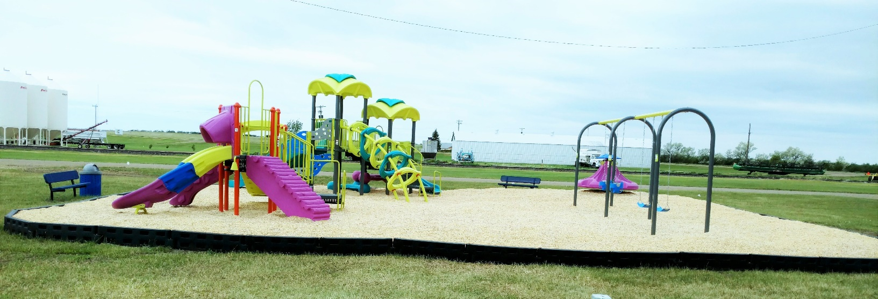
We are so grateful to have friends like you! Thank you for your continued support for this wonderful community that has raised so many wonderful people!!
The Town of Froid and Northern Lights Park

