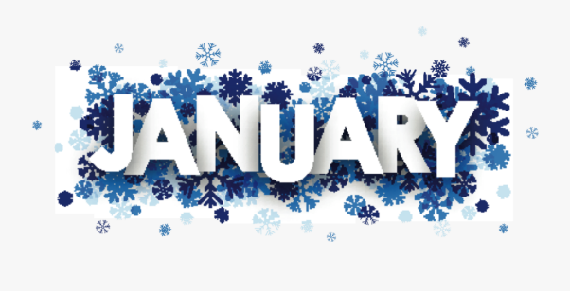

Bookbeat Froid Public Library

Pageturners Book Club: We will be reading Before We Were Yours by Lisa Wingate for January. We will meet to discuss this book on Wednesday, January 25th at 11:00.

Hopa Mountain: Our fall books are here! Included in this order are 3 board books: Hello Garage (with flaps and touch and feel pages), Baby Touch and Feel Animals, and Fire Engine No. 9. Also included in this order are An Elephant and Piggie Biggie (which has 5 Mo Willems stories) and We’re All Wonders by R.J. Palacio. All preschool children may come in and choose one of these books for free.
Along with the books we also receive book marks for parents (or any adult). Right now I have: Self Care Techniques for Parents, Social and Emotional Learning with Your Child, Go Green When You Clean, and one with a recipe for homemade all-purpose cleaner.

AWE Early Literacy Station: This computer specifically for kids is on the East wall of the library. It is a standalone computer that is not connected to the internet. It has over 70 preloaded programs covering reading, math, science, social studies, writing, art, music as well as a reference section. It has a colorful touchscreen that children can easily navigate.

Froid Library Hours: 11 to 5:00 Tuesday, Wednesday and Thursday
