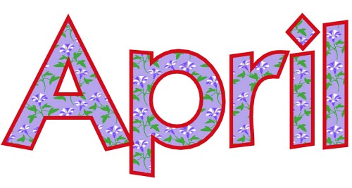

Bookbeat Froid Public Library

Pageturners: Our book for April will be Last Bus to Wisdom by Ivan Doig. This is the last book by Doig before he passed away in 2015. Doig has always been a big favorite with Montana readers.

Hopa Mountain: Our next round of books is here! The free books available are: The Lonesome Puppy by Nara, Frederick by Lionni (a Caldecott winner), Fox in Socks by Seuss(which comes boxed with a pair of socks!) and Pat the Bunny by Kunhardt.

I recently received a new book order:
New York Times bestsellers added to the collection are: An American Marriage by Tayari Jones and The Wife Between Us by Hendricks and Pekkanen. Other interesting additions include The Last Tudor for fans of Philippa Gregory, The Wedding Date which is a lighthearted romantic comedy, and The Quantum Spy, I Found You and The Gate Keeper – all thrillers.

Summer Reading Program: The theme this year is “Libraries Rock”. The program will tentatively start the week after the Fourth of July and run for 5 weeks. I’ll be sending home a letter later this spring and posters will be put up around town.

Froid Library Hours: 11:00 to 5:00 Tuesday, Wednesday, and Thursday

