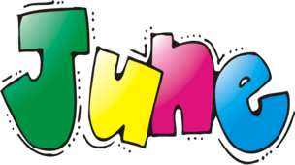

Bookbeat Froid Public Library

Pageturners: We will be taking the summer off but come in and tell me what you’re reading!

Hopa Mountain: The free books still available are: The Lonesome Puppy by Nara and Frederick by Lionni (a Caldecott winner).

Parental Control: Many children spend a lot of time on computers in the summer. The Butte Public Library has shared some steps for parents to take to protect their children online. Go to buttepubliclibrary.info/ and click on news and events at the top and then click on blog. Scroll down to parental controls and you will find instructions for setting parental controls on several different devices.

Summer Reading Program: The theme this year is “Libraries Rock”. The program will start Tuesday, July 10th and run for 5 weeks. Each session will start at 10:30 and go until 11:30. I’ll be putting up posters around town closer to July.

PBS Great American Read: Go to pbs.org/the-great-american-read and check out their 100 best-loved novels. You can check off the books you’ve read, vote for your favorite and best of all maybe get some ideas for books to read this summer. I also have copies of the list in the library if you want to just pick one up.

Froid Library Hours: 11:00 to 5:00 Tuesday, Wednesday, and Thursday

