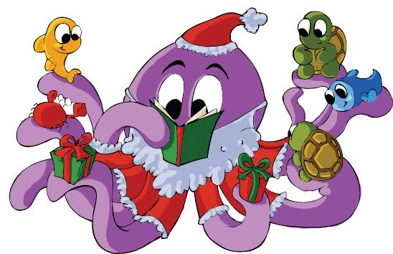December
This Photo by Unknown Author is licensed under CC BY-SA-NC

Bookbeat Froid Public Library

Pageturners Book Club: We will be taking a short break during December and will start on our next book in January. If you have any good ideas for books we should read, let me know.

Hopa Mountain: We have received our books for the fall round! These books are free to keep for any preschooler. The books we received this time are: The Very Eric Carle Treasury, Hand in Hand by Wells, Who’s Hungry by Hacohen, My Heart Fills With Happiness by Smith, Open Very Carefully by Bromley, and Mouse is Small by Murphy.

New York Times bestsellers:
We have several current bestsellers available in the library.
Fiction: Nonfiction:
Where the Crawdads Sing by Delia Owens Educated by Tara Westover
The Water Dancer by Ta-Nehisi Coates
The Institute by Stephen King
The Dutch House by Ann Patchett
The Testaments by Margaret Atwood
The Giver of Stars by Jojo Moyes

Local author: Adam Parker, who attended Froid School when his father was superintendent here, has donated a copy of his book: The Divine Proportions of Luca Pacioli to our library.

Froid Library Hours: 11 to 5 Tuesday, Wednesday, and Thursday

