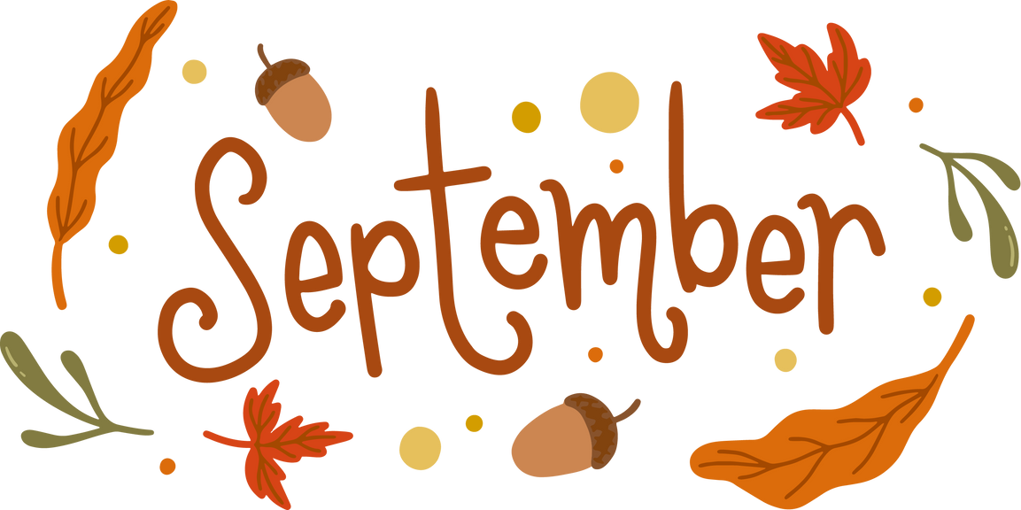

Bookbeat

Froid Public Library

Hello everyone! My name is Cheyenne, and I have been selected to take over Sheri’s position here at the library. Let's hope I can fill such amazing shoes from someone who has been a huge role in this community!

I still have a few amazing little books that are free for kids here at the door when you walk in, and I have some at the end of the bookshelves on a table near the back. Please feel free to come look and grab them!

What have I been reading?? Well, I haven't picked up a book in a little while but now that I am here the selection is ENDLESS! And I am always open to suggestions.

Friends of the Library have chosen a date for the Pie social to be on Thursday October 17th this year at 3 until 6. We are thankful to have a loving community that wants to support our little library!

I will definitely keep up the Bookbeat newsletter to keep everyone updated! Hope to see you here at the library!

