June
Bookbeat Froid Public Library

Summer Reading Program: The summer reading program at our library will be held every Tuesday in July from 10:00 to 11:30. The theme this year is A Universe of Stories. All kids from those entering kindergarten through those who have just finished 6th grade are welcome.
(I’m also thinking about doing a junior high/high school book club if there is enough interest.)

Read With Your Kids This Summer! Research has shown that children who do not read in the summer can lose two to three months of reading skills while children who do read tend to gain a month of reading proficiency.

Montana Outdoors: Starting with the May/June issue we will be getting Montana Outdoors magazine. This is being provided free of charge to all libraries by the Montana Department of Fish, Wildlife and Parks and is a very high quality magazine.

1000 Books Before Kindergarten: If you have a preschool child or grandchild sign up for our program! It’s easy and free. When you sign up they get a folder with a reading record and stickers. Every time you read a book for your child they get to put a sticker on the sheet. Even if you read the same book several times, they get a sticker every time. When the sheet is full bring it into the library and your child gets a sticker with the # of books read and a small prize.

Hopa Mountain: We have received our books for the spring round. These books are free to keep for any preschooler. The books we have this time are: The Eye Book, The Many Mice of Mr. Brice, Thanks From the Very Hungry Caterpillar, The First Strawberries, and Nicky Goes to the Doctor.

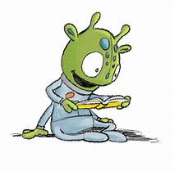
Froid Library Hours: 11 to 5 Tuesday, Wednesday, and Thursday

